**Figure Legends**

Fig. 1. Sampling locations for each unique crop and non-crop site. All cultivated dry pea fields were spring-planted fields in rotation with cereals. Non-agricultural sites included open public lands or lands that gave permission to sample. Color indicates presence or absence of PEMV at a given transect. Repeated sampling locations 150m to 250m in proximity not shown to prevent overlapping points on the map.

Fig 2. Cumulative aphid density (log transformed) for legume hosts found among all surveys. Bar colors indicate whether a host plant was discovered with PEMV RNA.

Fig. 3. Cumulative plant coverage for non-crop legumes found among all surveys; hairy vetchwas the most common. Bar length indicates the cumulative coverage among our sites.

Fig 4. Probability predictions from GLMM (binomial fit) for pea aphid presence or absence in transects fitted to the abundance of non-crop host hairy vetch. The line indicates estimates means from GLMM, and the shaded area indicates the standard error of those model predictions. As hairy vetch coverage increased, aphids were more likely to be present in plant communities.

Fig. 1

Fig. 2

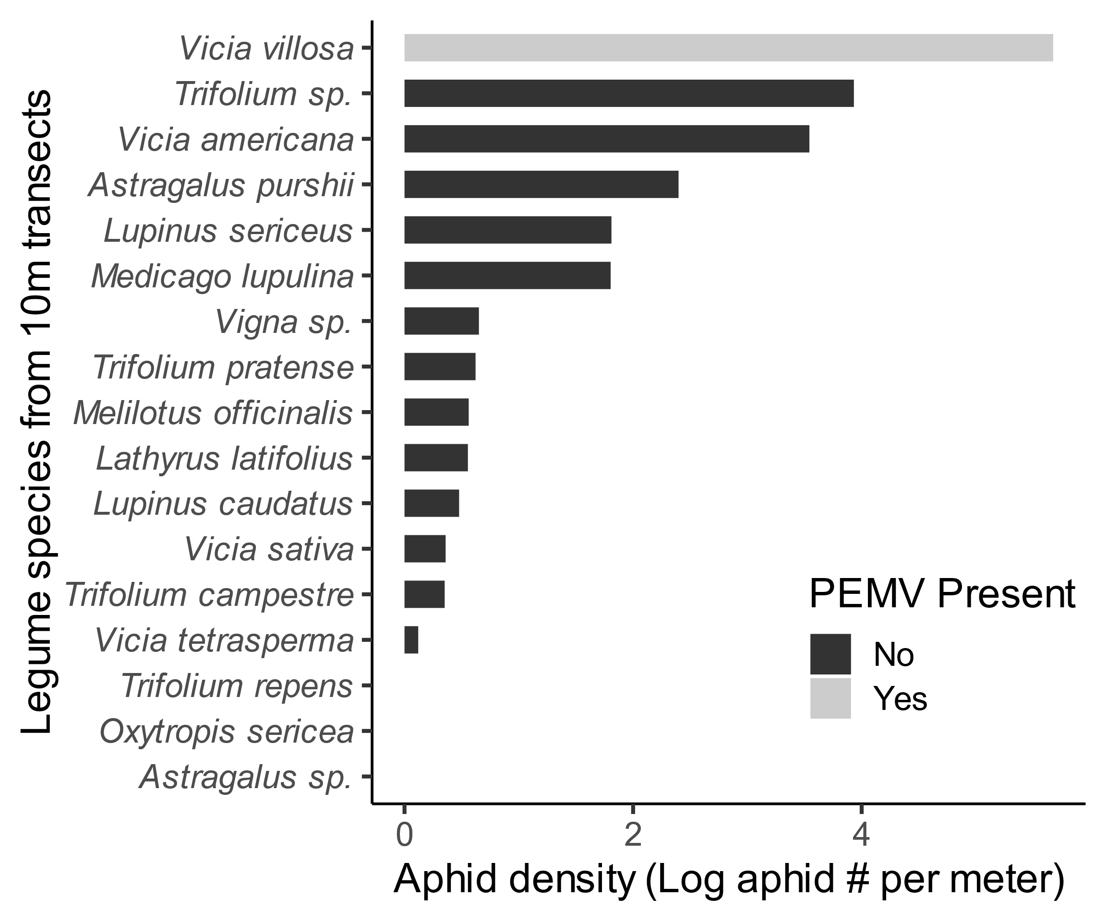

Fig. 3

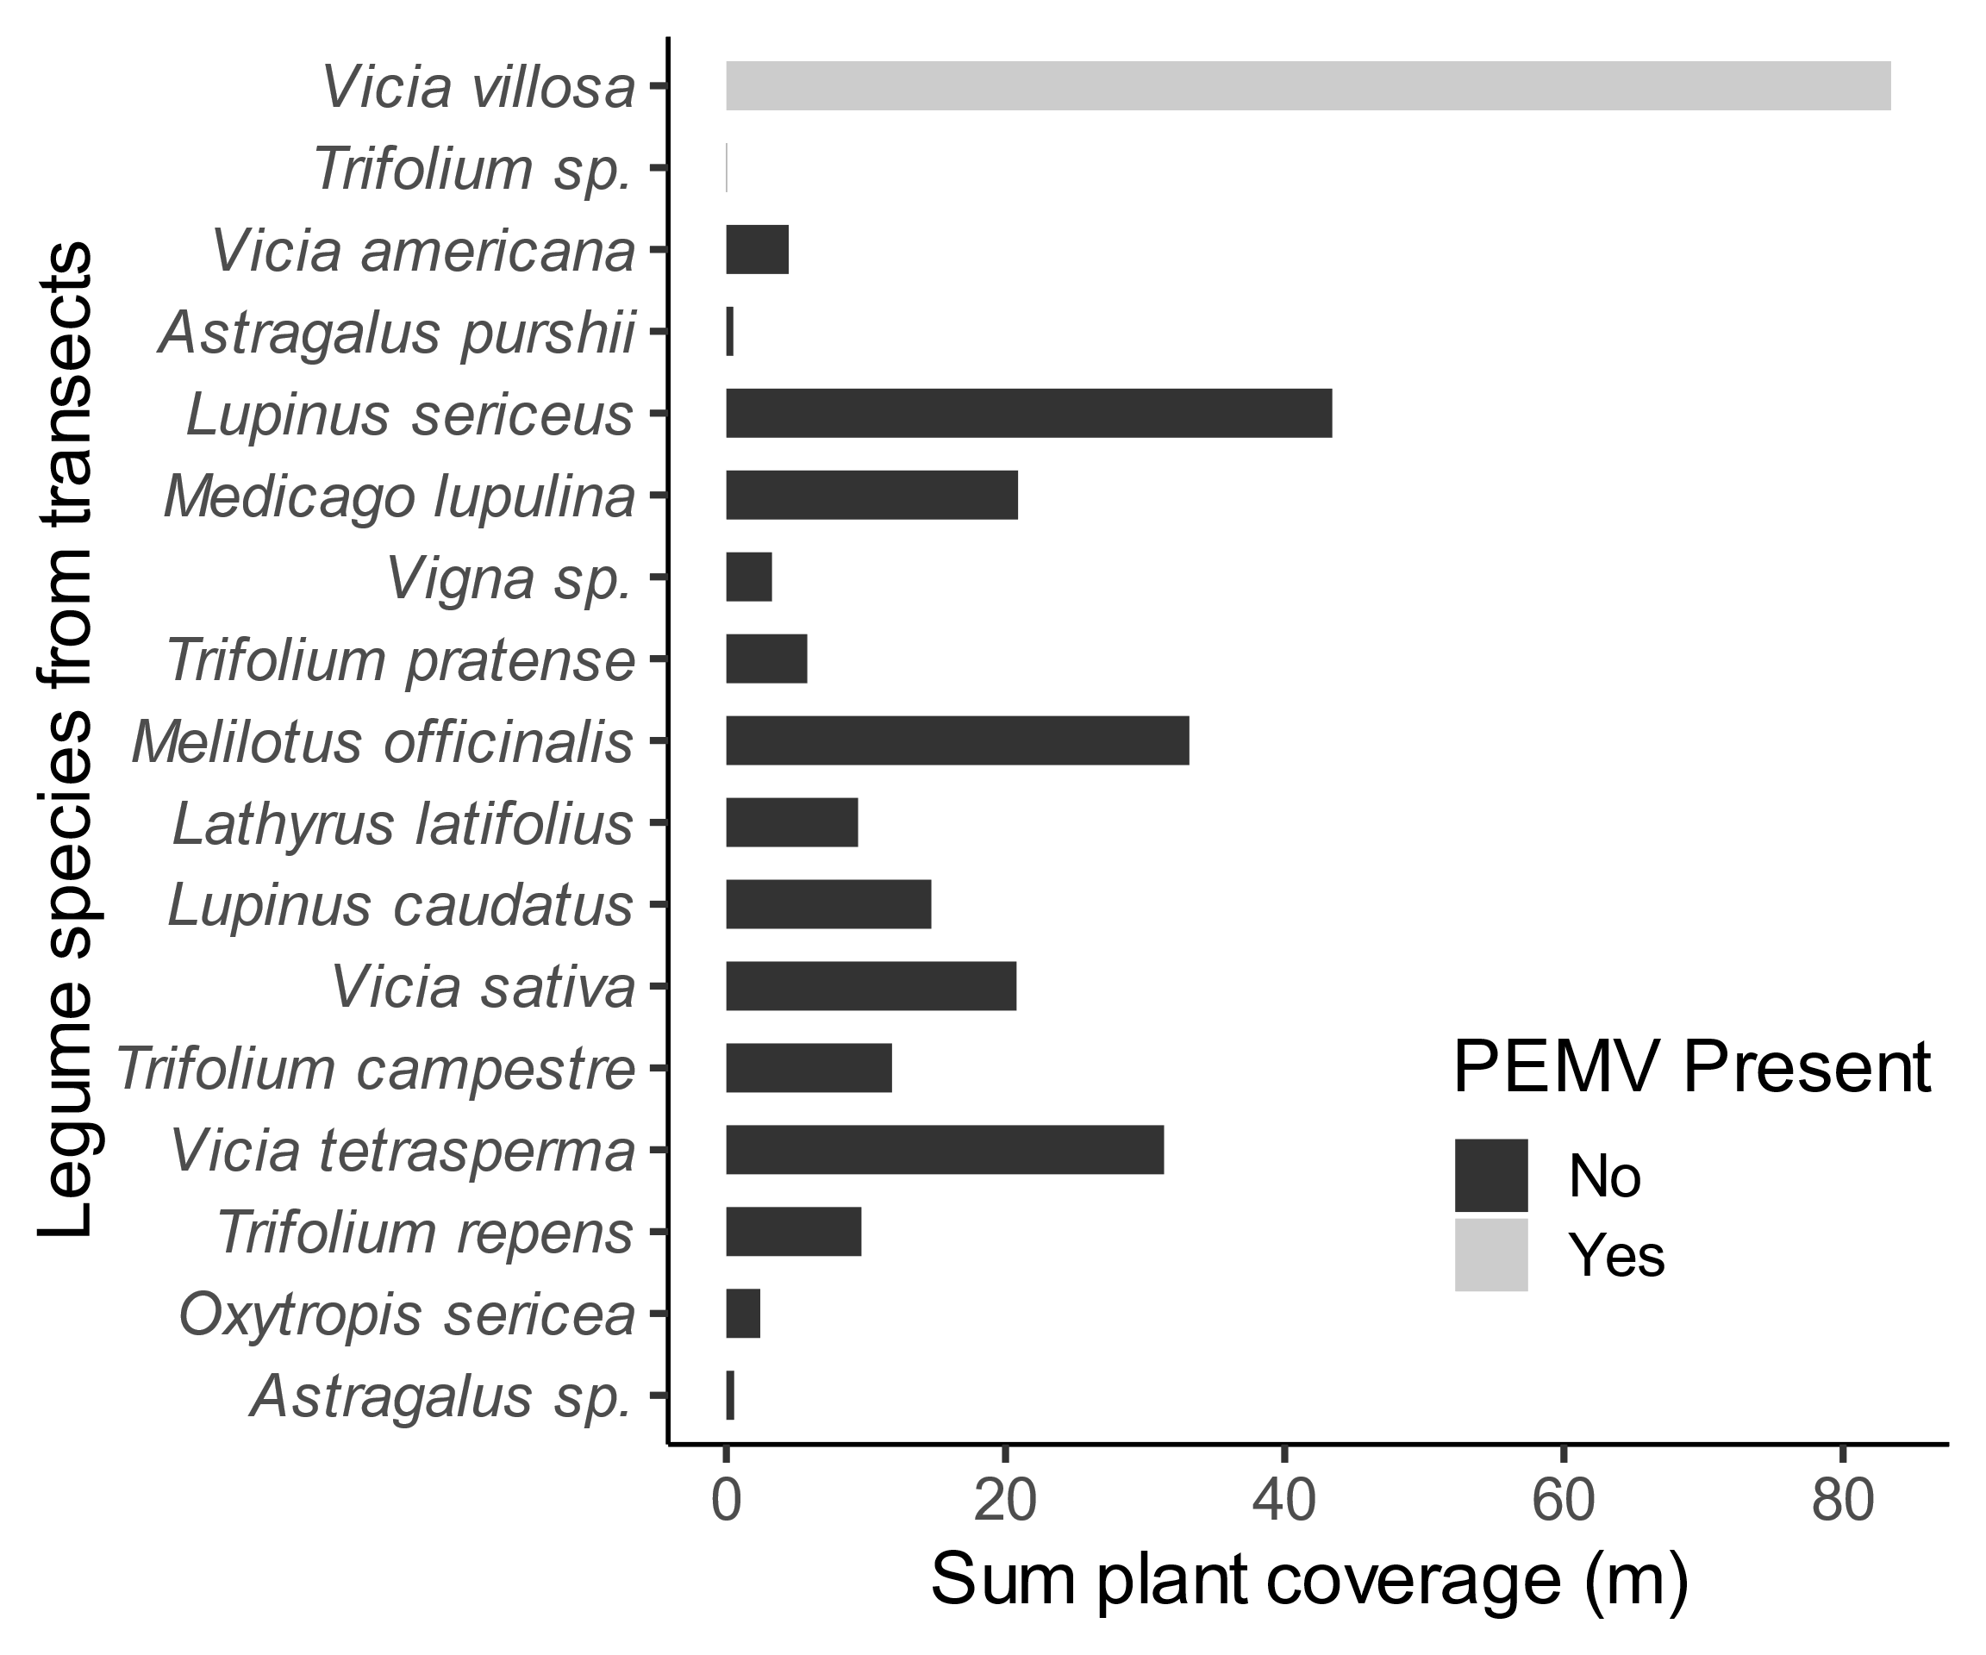

Fig. 4

